Below are instructions to register as a new user and complete your exam. Just a friendly reminder, you must complete the exam in order to receive your 2.5 CME credits and 2 year certification.
Please head over to https://education.svin.org
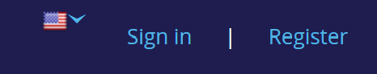
Click the register button and create your free account.
Once you register you will click ‘Search Catalog’ where you will proceed to choose Advanced Stroke Emergency Support (ASES).

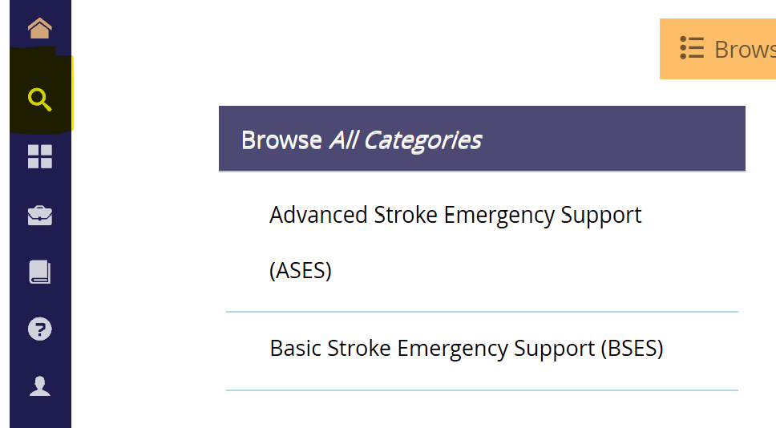

Add the course to your cart and ‘Secure Checkout’. From there you will be able to enter your ‘Coupon Code’ and complete your exam.
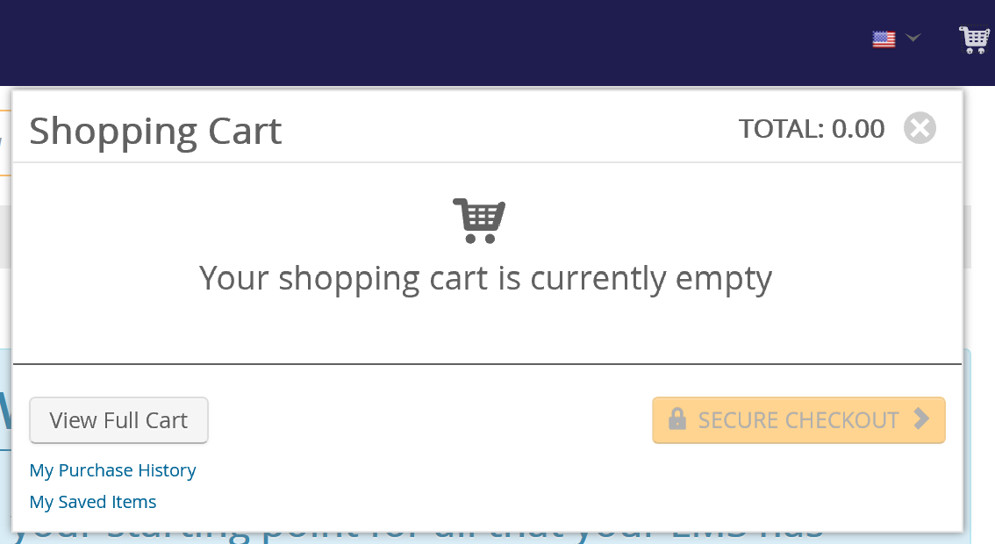

Your course code is: ESOWSO2020

